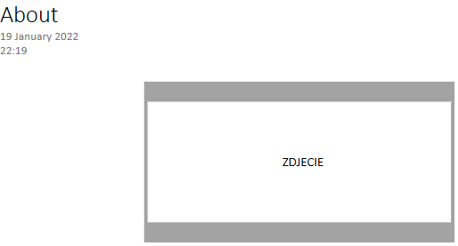

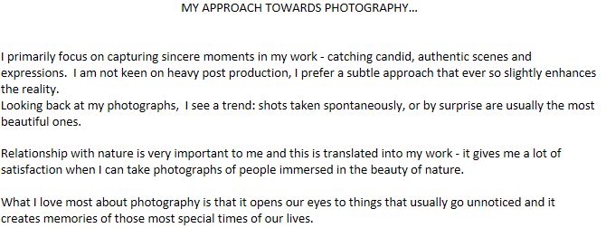

Po tej czesci ma byc taka wstawka - po kliknieciu lets chat, przenosi do zakladki Contact



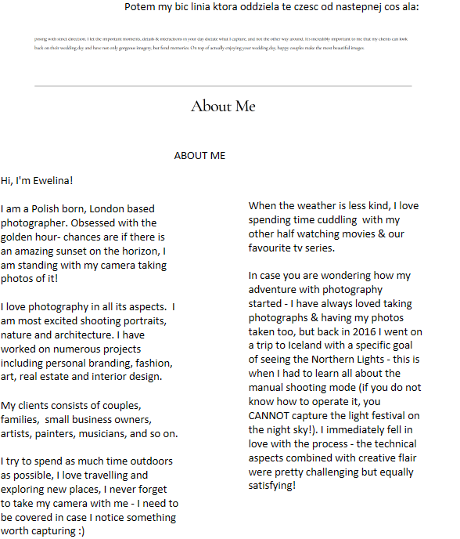

|  |  |  |  |  |  |
| --- | --- | --- | --- | --- | --- |
|  |  |  |  |  |  |
|  |  |  |  | MORE ABOUT ME |  |
|  |  |  |  |  |
|  |  |  |  |  |
|  |  |  | | |
|  |  |  |  |  |

I am also a co-owner of Arch & Peony - a boho prop hire company, covering the prefect elopement wedding needs across the UK :)

